Compression Only One-Way Gaps

For every node on the surfaces selected, this API creates a new matching, permanently constrained node and a gap element. In addition, it creates, or finds and existing coordinate system whose X-Axis is normal to the surface at the node. This way, using the linear contact functionality of NX Nastran, one gets compression only stiffness.

If you have linear contact set up elsewhere in your model, there is nothing else to do except run it. If you do not have linear contact, you will need to at a BCSET=1 command to the Case Control section of the input file –

Consider this simple model, without one-way gaps on the bottom face –

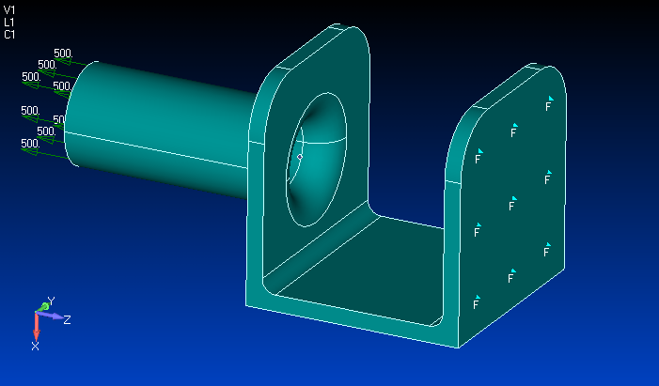

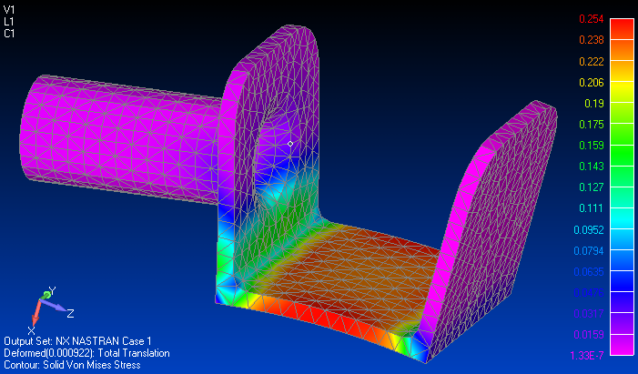

With Compression Only Gaps and BCSET=1

